EXPERIMENT 2. DOUBLE THICKNESS DIELECTRIC PLATE
In order to determine two unknown optical quantities n and k of any material one has to measure at least two experimental optical characteristics as well. In this experiment optical parameters n and k of various samples are determined by measuring the transmission coefficients of two plates of different thicknesses. If the thicknesses d₁ and d₂ of the samples are large enough so that there are no multiple reflections of the radiation between the faces of the plates, the transmission coefficients can be written as:

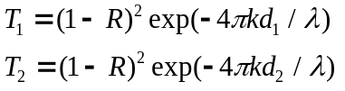 (1),

where R is the reflection coefficient of a separate face of the plate which is given by:

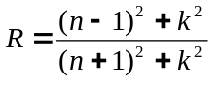 (2).

Having the set of two equations (1) enables one to determine both, refractive and absorption indexes of the material n, k.

Quasioptical arrangement of the of the measurement scheme is shown in Fig.1.
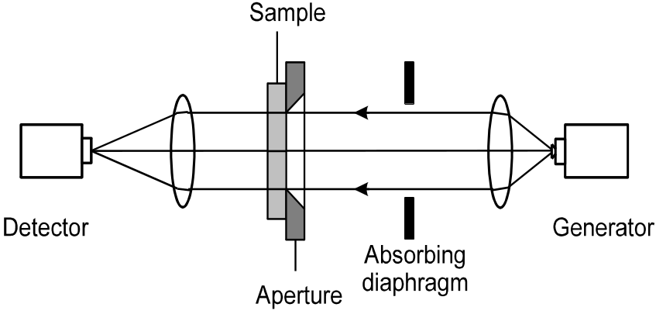
Fig.1. Quasioptical arrangement for measurements of millimeter wave transmission coefficients of solids. The transmission coefficient is determined as the ratio of detected intensities with and without the sample at the aperture: T=I_{sample}/I₀.

EXPERIMENTAL PROCEDURE INCLUDES measurement of the transmission coefficients of various samples and determination of their optical parameters n and k using expressions (1,2).

EXPERIMENT 3. MILLIMETER WAVE REFLECTIVITY OF SOLIDS

Experimental arrangement for the quasioptical reflectivity measurements is shown in Fig.1.

Fig.1. Quasioptical arrangement for measurements of the millimeter wave reflection coefficients of solids. The reflection coefficient is determined as a ratio of the detected intensities with the sample and with the reference metal mirror at the aperture: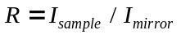.
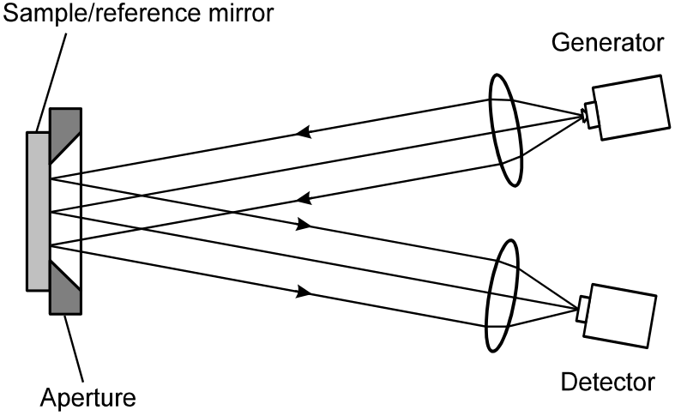

EXPERIMENTAL PROCEDURE INCLUDES measurement of the reflection coefficients R of various materials. For low-absorbing samples, k<<n, and thus the refractive index can be calculated using the above expression R=(n-1)²/(n+1)². The same materials as in the previous experiment can be measured and the n values obtained using the transmission and reflection coefficients measurements are compared.

